**NAME- DEVANSHU SURANA**

**ELECTIVE ROLL NO-BT1-18**

**PANEL ROLL NO- PC-23**

**PRN-1032210755**

**PANEL-C**

**Lab Assignment - 08**

**Title: -** Demonstrate the Blockchain in Python or Java

**Aim: -** To illustrate the fundamental concepts and implementation of a blockchain using Python or Java programming languages.

**Objectives: -** **1)** Understand the basic principles of blockchain technology.

**2)** Implement a simple blockchain data structure.

**3)** Create a mechanism for adding new blocks to the blockchain.

**4)** Implement proof-of-work consensus mechanism.

**5)** Demonstrate verification of transactions within the blockchain.

**6)** Explore potential applications and extensions of blockchain technology.

**Theory: -**

Introduction to Blockchain Technology:

Blockchain is a distributed ledger technology that enables secure and transparent record-keeping across multiple participants in a network. It consists of a chain of blocks, each containing a list of transactions. These blocks are cryptographically linked, forming an immutable and tamper-resistant ledger.

Blocks and Transactions:

A block in a blockchain contains a batch of transactions, a timestamp, and a reference to the previous block, forming a linked list structure. Each transaction represents a transfer of assets or data between participants in the network. Blocks are sequentially added to the blockchain, ensuring the ledger's integrity.

Consensus Mechanisms:

Consensus mechanisms are protocols to achieve agreement among nodes in a decentralised network. Proof-of-work (PoW) is a mechanism where participants (miners) compete to solve complex mathematical puzzles to validate transactions and create new blocks. PoW ensures the security and integrity of the blockchain by making it computationally expensive to alter historical records.

Mining and Validation:

Mining is adding new blocks to the blockchain by validating transactions. Miners use computational power to solve cryptographic puzzles and append new blocks to the chain. Once a miner successfully mines a block, other nodes broadcast it to the network for validation. Validated blocks are added to the blockchain, and miners are rewarded for their efforts.

Security and Immutability:

Blockchain achieves security through cryptographic techniques such as hashing and digital signatures. Each block contains a cryptographic hash of the previous block, making it computationally infeasible to alter historical records without affecting subsequent blocks. Additionally, digital signatures ensure the authenticity and integrity of transactions, preventing unauthorised modifications.

Smart Contracts:

Smart contracts are self-executing contracts with the terms of the agreement directly written into code. They enable automated and trustless transactions between parties, eliminating the need for intermediaries. Smart contracts are deployed on blockchain platforms like Ethereum, allowing for decentralised applications (DApps) and programmable digital assets.

Screenshots:

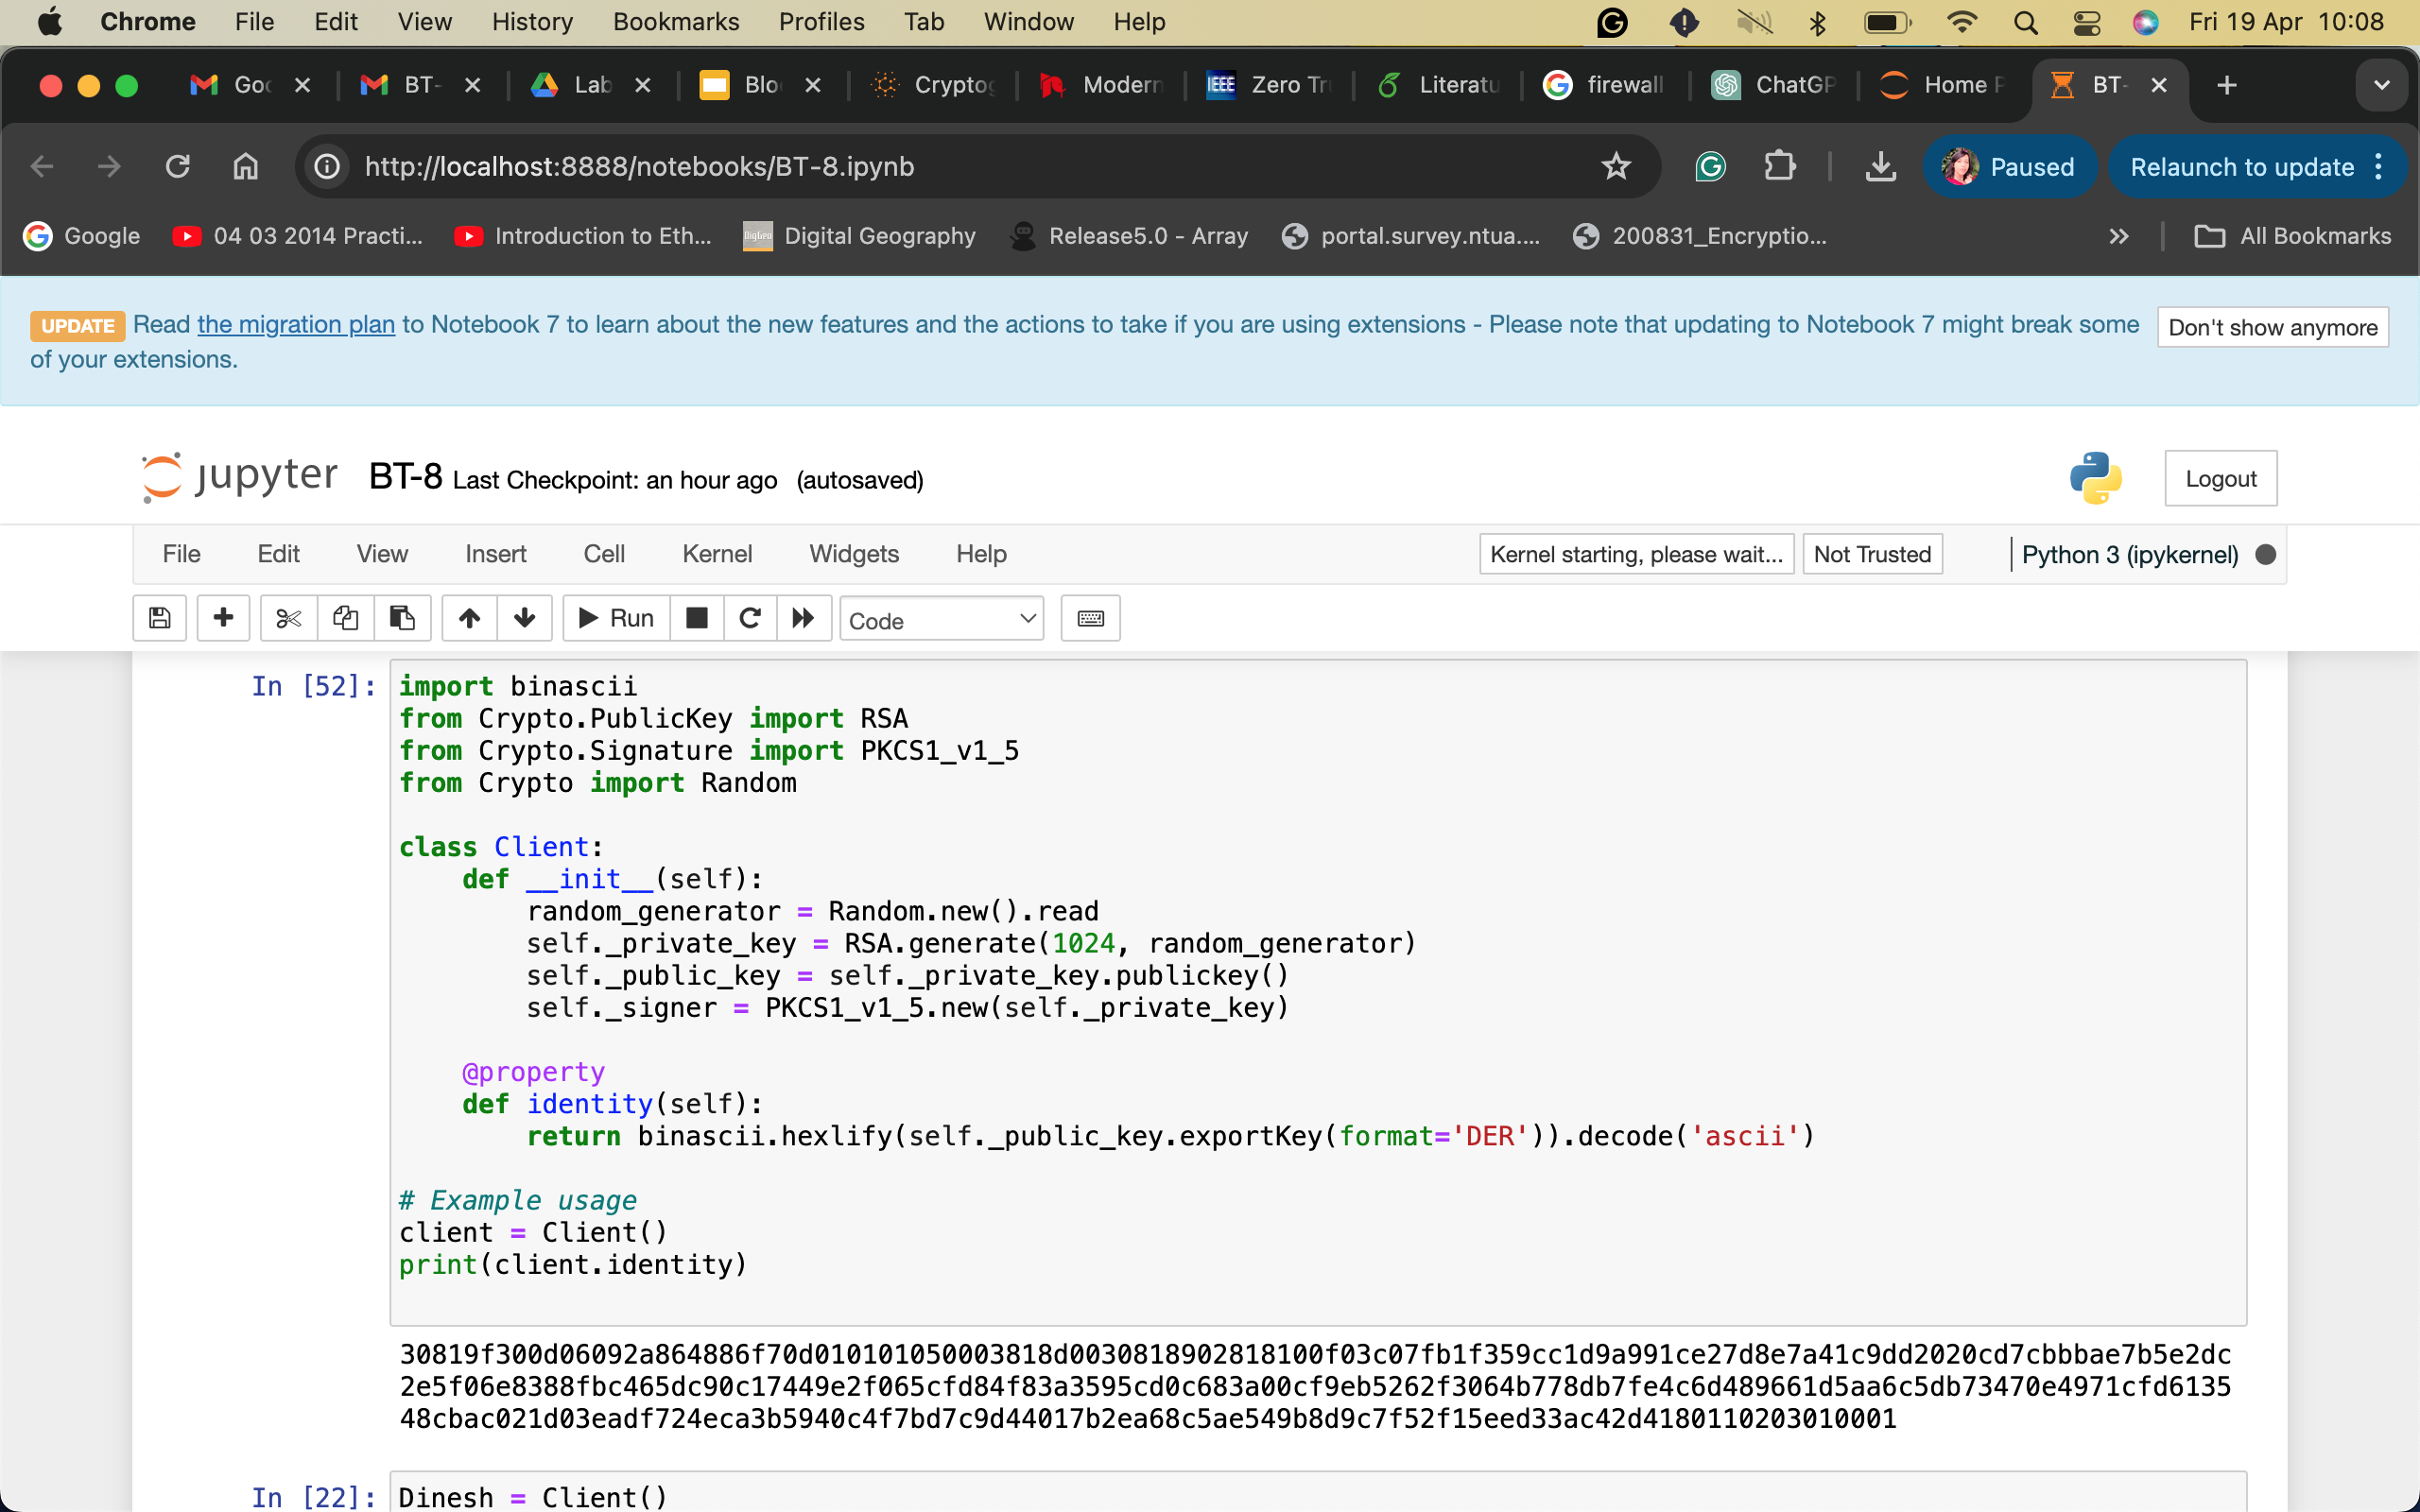

Figure 1: This image shows the client identity, a hexadecimal value randomly generated of 1024 bits. These are the public and private keys that are generated for the client.

Figure 2: The public key that is generated will be returned as an instance of the MyClass as the identity of the Client. Anybody could send virtual currency to you using this identity and it will get added to your wallet.

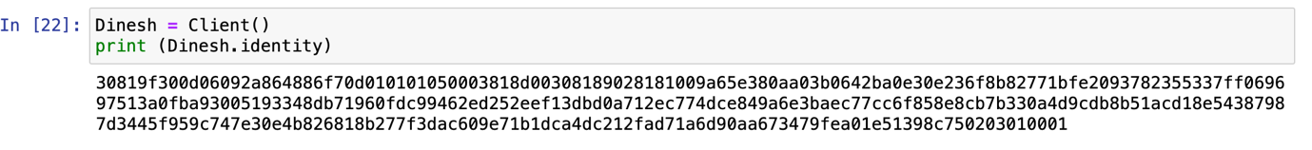

Figure 3: The public key generated is printed in the figure. We can see that the public key is a hexadecimal value used in the transaction and can be accessed by the receiver.

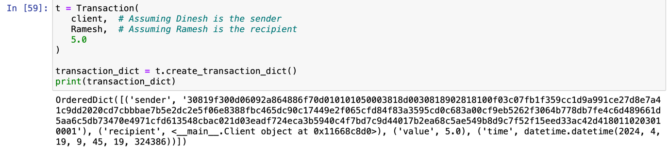

Figure 4: The figure shows a sample transaction setting with the client and the recipient Ramesh. The value sent from the client is 5.0. A timestamp is also included in the transaction. The whole transaction is printed.

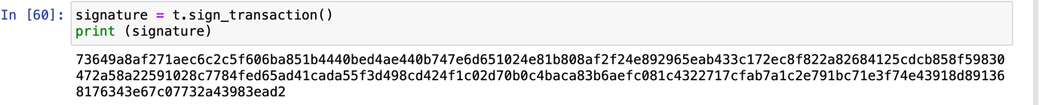

Figure 5: The signature is the main indication that the transaction is valid. It tells both the client and the receiver that the transaction is valid and approved by both parties.

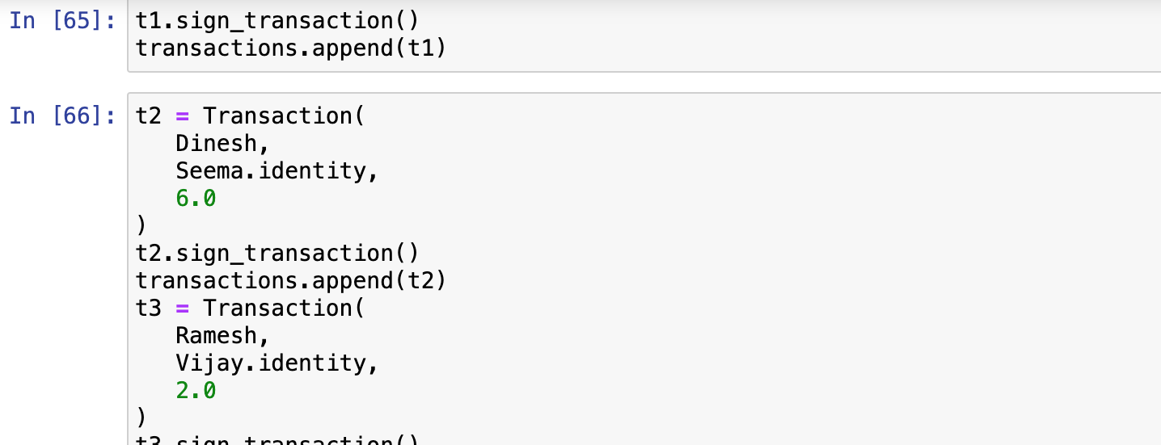

Figure 6: Here, multiple transactions are shown. The transactions are displayed in a list. For example, t2 occurs between Dinesh and Seema and transfers the value of 6.0. t3 occurs between Ramesh and Vijay and transfers the value of 2.0.

Figure 7: Here, all the multiple transactions are displayed. For distinction, the transactions are separated by a dashed line. We print all transactions beginning with the first transaction except for the Genesis transaction, which was never added to this list.

FAQs:

1. What is blockchain technology?

- Blockchain technology is a decentralised ledger system that securely records transactions across multiple parties in a network. It enables transparency, security, and immutability of data without the need for a central authority.

2. How does the proof-of-work consensus mechanism work?

- Proof-of-work is a consensus mechanism where miners compete to solve complex mathematical puzzles to validate transactions and create new blocks. This process involves significant computational power and ensures the integrity and security of the blockchain.

3. What are some real-world applications of blockchain beyond cryptocurrency?

- Blockchain technology has various applications beyond cryptocurrency, including supply chain management, healthcare data sharing, voting systems, decentralised finance (DeFi), and identity verification.

4. Is blockchain technology secure?

- Blockchain technology is inherently secure due to its cryptographic principles, decentralised nature, and consensus mechanisms. It provides tamper-resistant data storage and ensures transaction integrity through cryptographic hashing and digital signatures.

5. What are the limitations of blockchain technology?

- Despite its benefits, blockchain technology faces challenges such as scalability, energy consumption (in proof-of-work systems), regulatory concerns, and interoperability between different blockchain networks.

Conclusion:

In conclusion, blockchain technology represents a transformative innovation with profound implications across various industries. Throughout this exploration, we've delved into the foundational principles, mechanisms, and applications of blockchain in both theory and practice.

Blockchain's decentralized nature, secured through cryptographic techniques and consensus mechanisms like proof-of-work, ensures trust and transparency in transactions without intermediaries. Its immutable ledger provides a tamper-resistant record of data, fostering accountability and reducing the risk of fraud.

Beyond its roots in cryptocurrency, blockchain has applications in supply chain management, healthcare, finance, voting systems, and more. It offers solutions to challenges such as data security, transparency, and efficiency.

However, while blockchain holds immense promise, it also faces hurdles related to scalability, energy consumption, regulatory complexities, and interoperability. Addressing these challenges will be crucial for unlocking blockchain's full potential and realising its benefits on a global scale.

As we continue to explore, innovate, and adapt blockchain technology, it's essential to maintain a nuanced understanding of its capabilities, limitations, and ethical considerations. By doing so, we can harness the power of blockchain to drive positive change, foster innovation, and build a more transparent and equitable future.